**GSM Handoff/ 2G Handoff :**

* **﻿**Handoff or Handover is the process of transferring a mobile station from one channel or base station to the another. It is defined as a mechanism to hand over the control of a mobile device to the neighbouring cell.
* The core network can perform handovers at various levels of the system architecture.

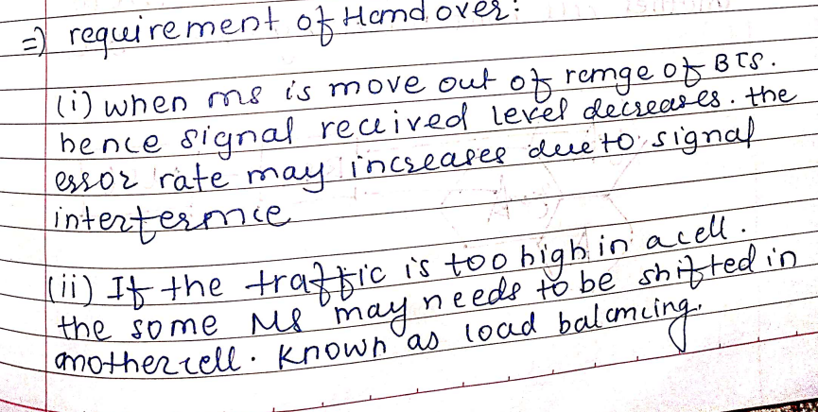

There are two types of handoffs. They are:

* Hard Handoff
  + In hard handoff the radio link must be dropped for a small amount of time before it can be taken over by another base station.
  + A call that is in progress is redirected not only from a base station to another base station but from current transmit- receive frequency pair to another frequency pair. A break in call transmission is called as call drop or call cut-off.
  + The handover occurs in a few milliseconds. Handover to other cell is needed when the signal strength is low and error rate is high.
  + The GSM systems perform hard handovers.
* Soft Handoff
  + The 3G CDMA systems support soft handover. Soft handover indicates a mobile station (MS) at the boundary of two adjacent cells does not suffer call drops because of handover in the boundary region. A mobile can be connected to several base stations simultaneously.

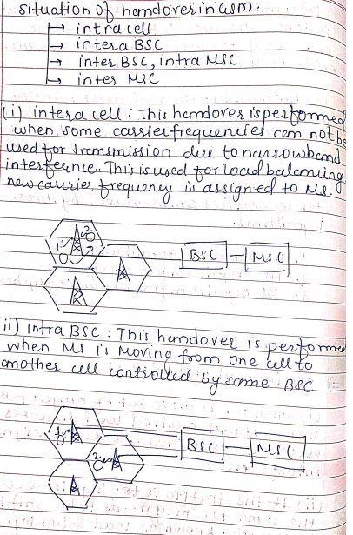

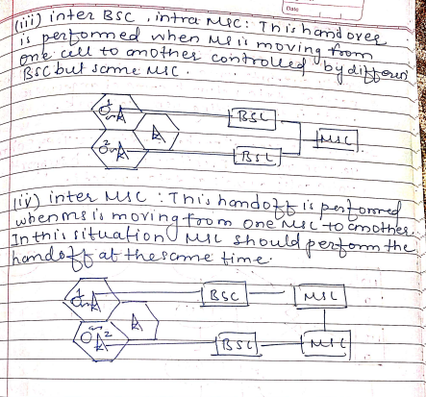

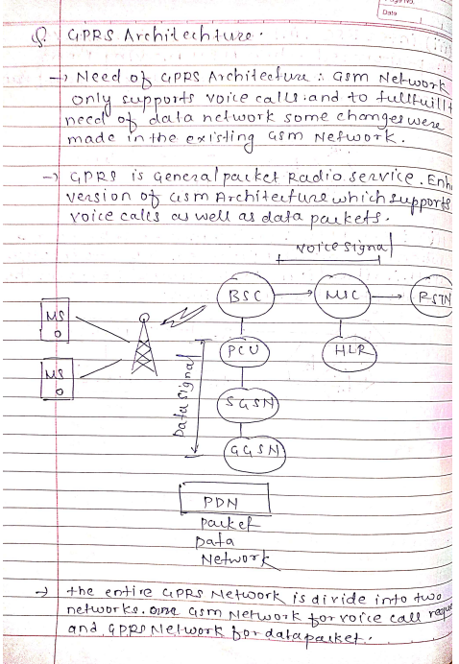

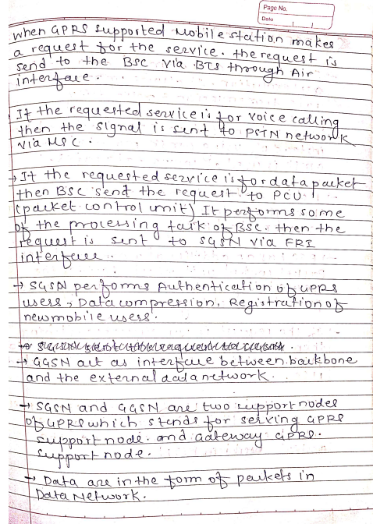

Mobility Management.

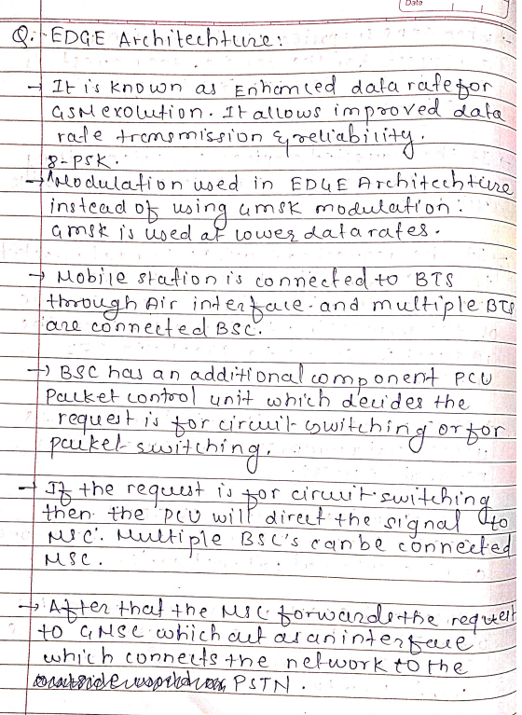

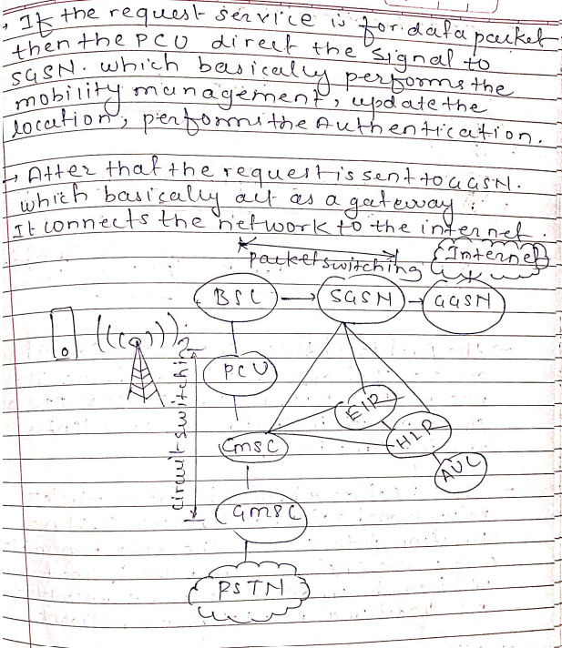

With the help of HLR, VLR, EIR and AUC.

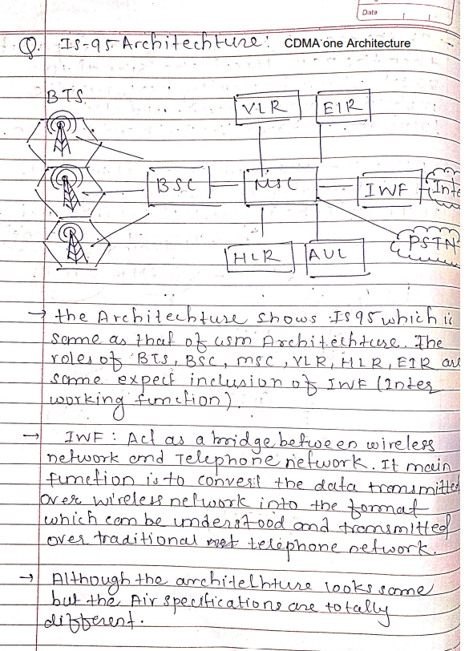

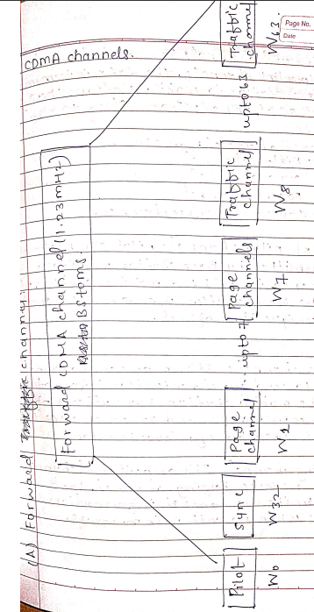

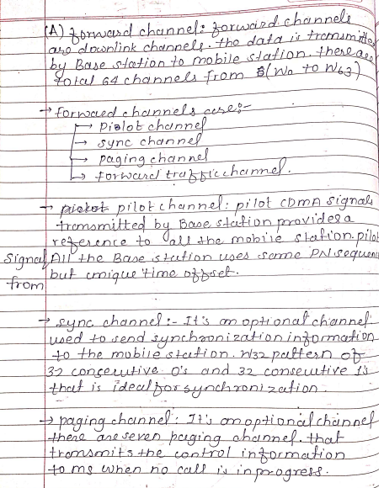

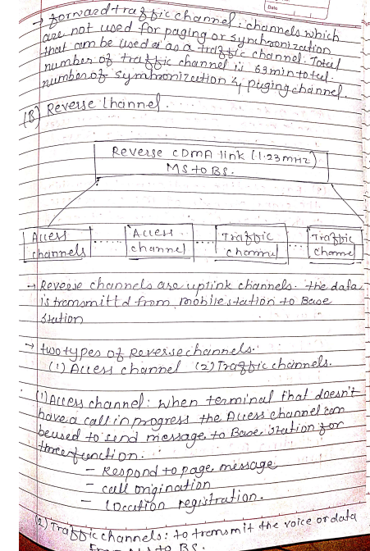

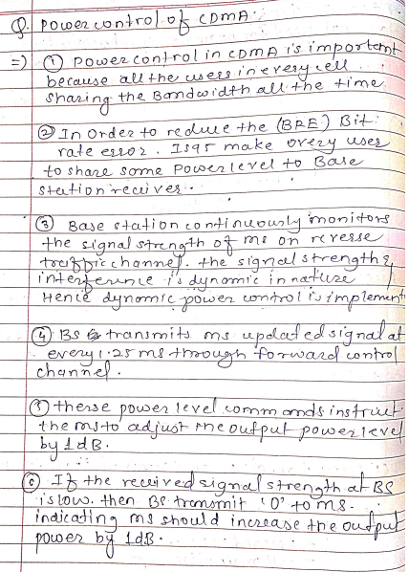

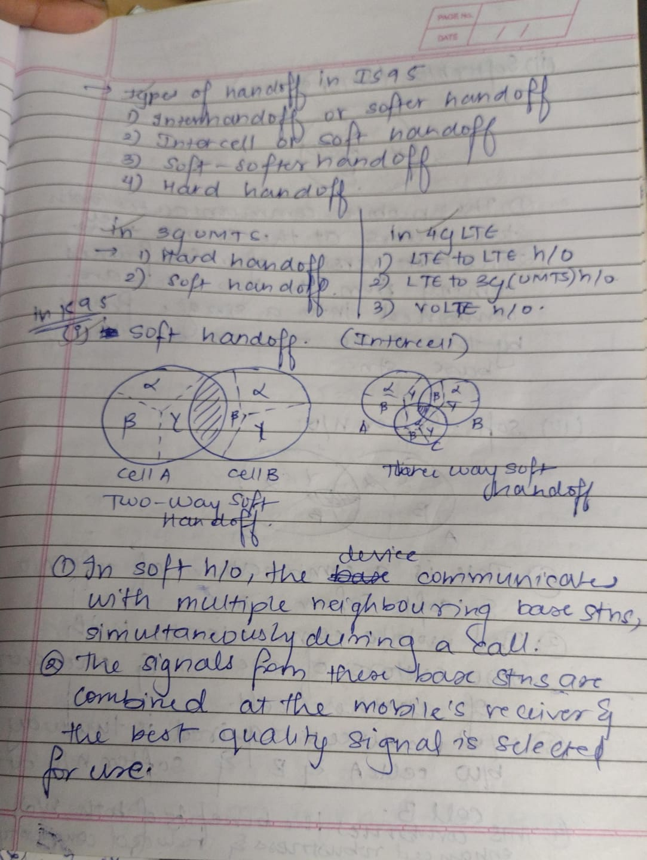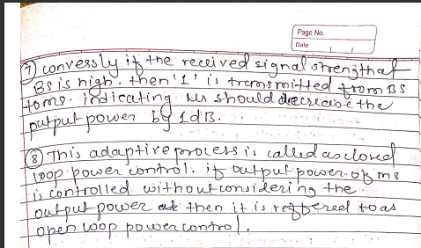

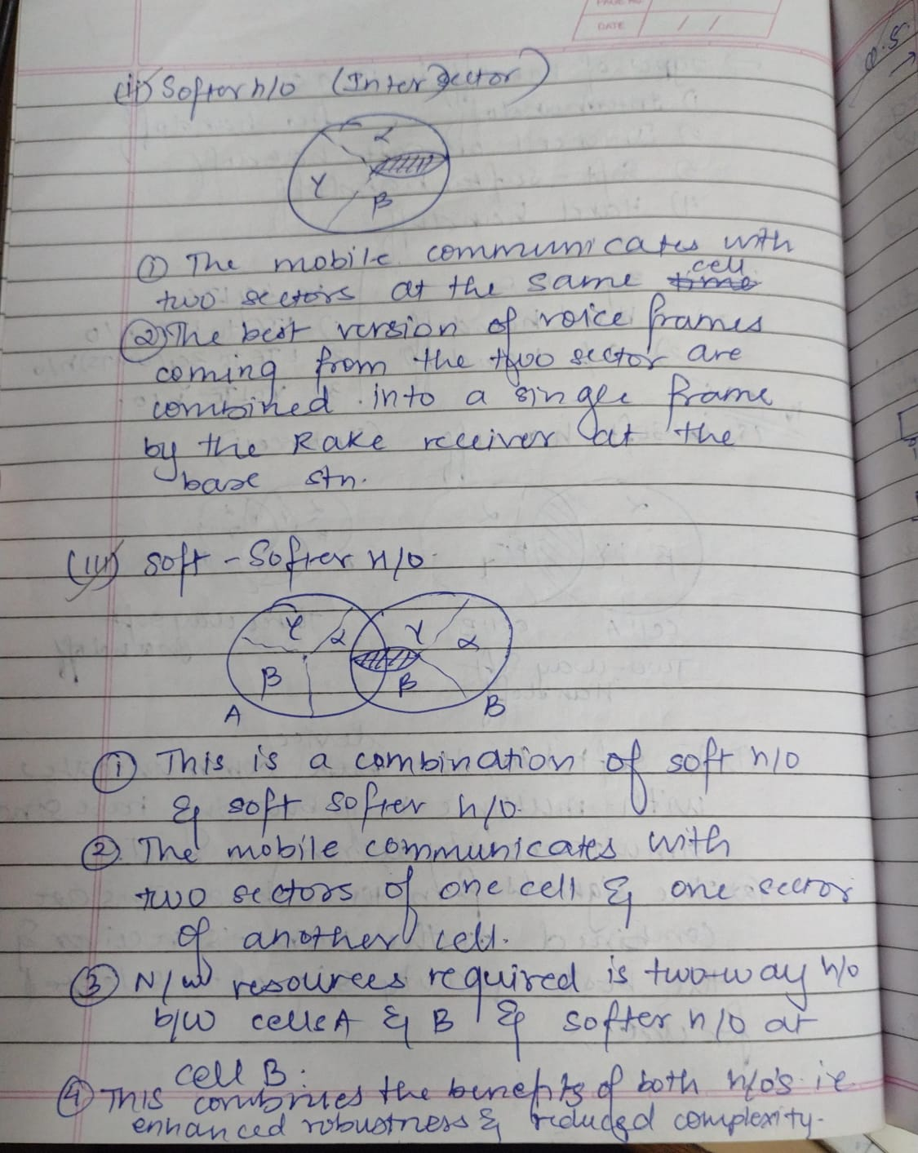

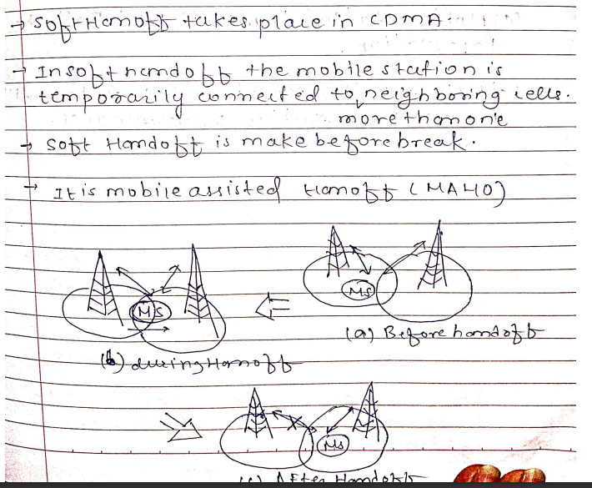

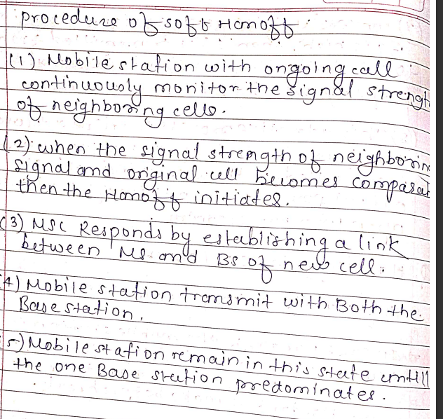

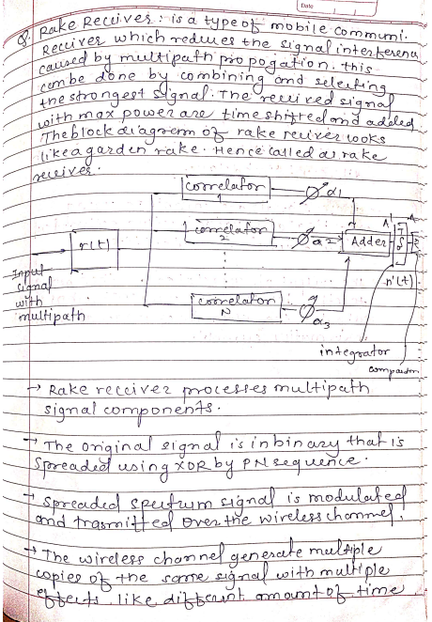

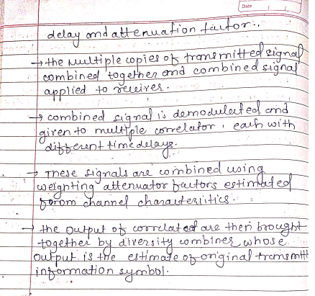

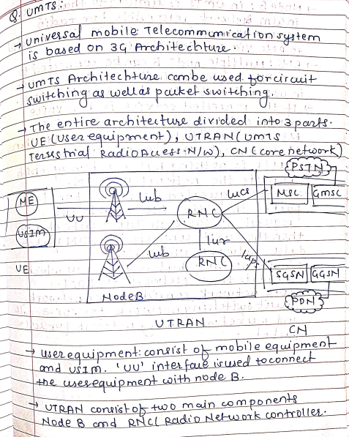

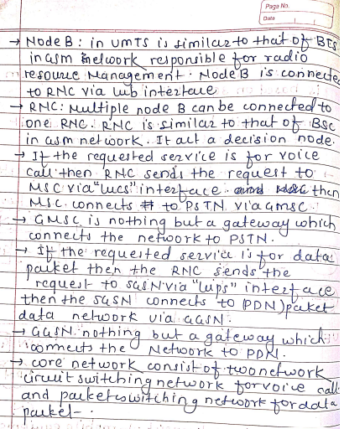

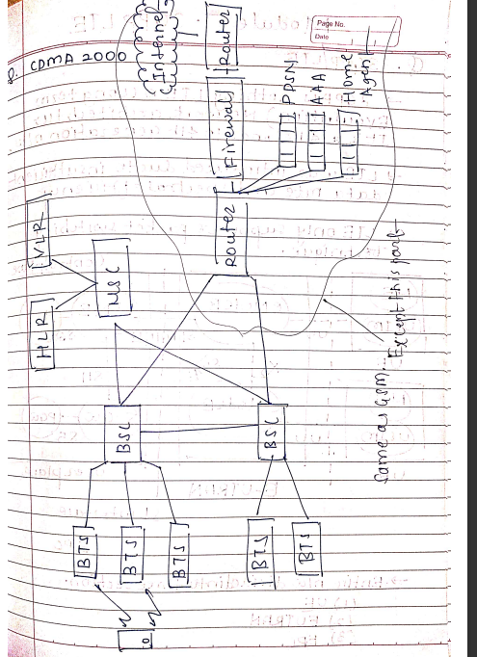**CDMA-2000**

**PSTN**

**Router**

* The function of the Router is to route the packets between the various network elements within the CDMA 2000 system.
* The task of the Router is to send and receive packets to and from the internal network to the offnet platforms.

**Firewall**

* A firewall is required to ensure that security is maintained while connecting to offnet data applications.

**Packet Data Serving Node (PDSN)**

* It is a new component in the CDMA 2000 system in comparison to the Cdma One networks.
* It is an essential element in the treatment of packet data services that will be offered.
* The function of PDSN is to support packet data services.
  + Receives service parameters for the mobile client from the AAA server.
  + It collects usage data that are relayed to the AAA server.
  + It routes packets to and from the external packet data networks.

**Authentication, Authorization and Accounting (AAA)**

A new component is the AAA. With CDMA 2000 network it provides authentication, authorization and accounting functions for the packet data network.

**Home Agent (HA)**

* It is an important component to the CDMA2000 packet data service network.
* The home agent performs many tasks. It tracks the location of the mobile IP subscriber as it moves from one packet zone to another, while tracking the mobile, the Home Agent will ensure that the packets are forwarded to the mobile itself.

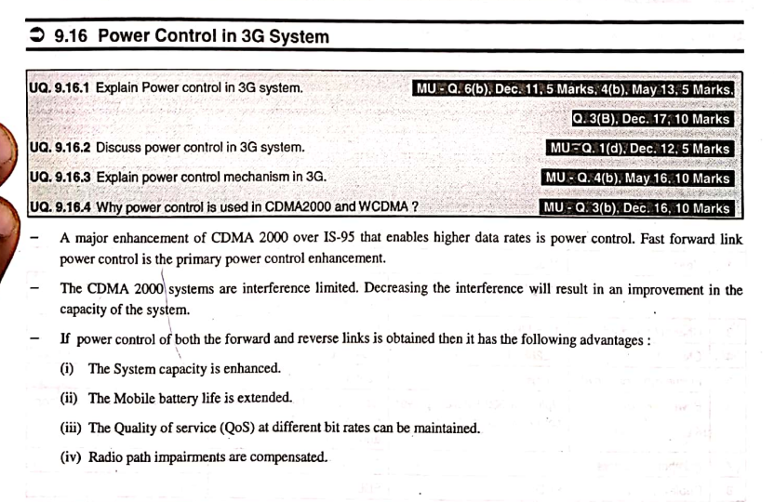

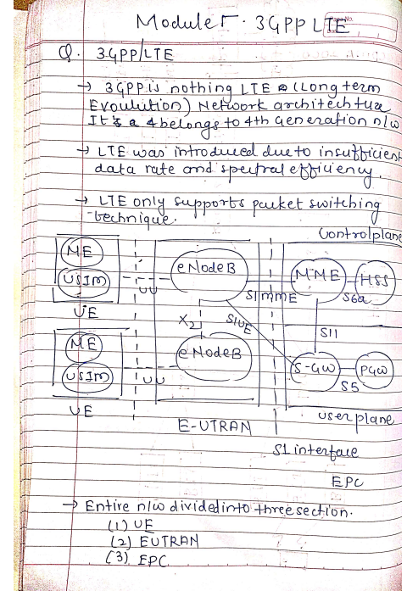

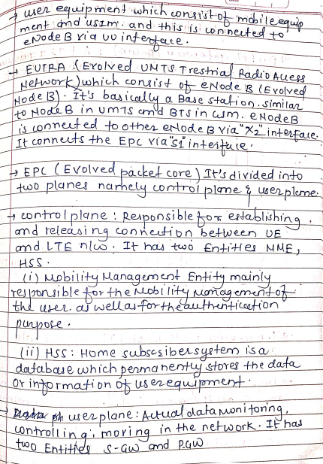

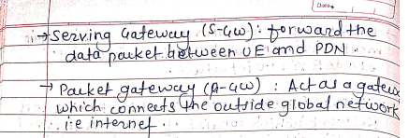

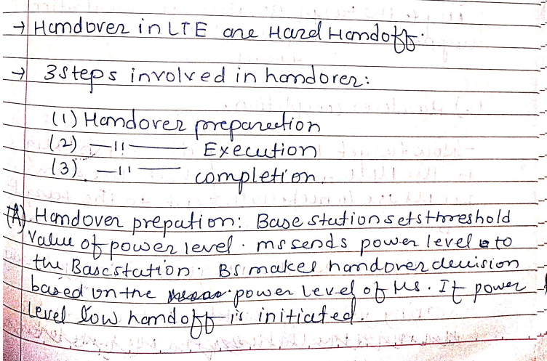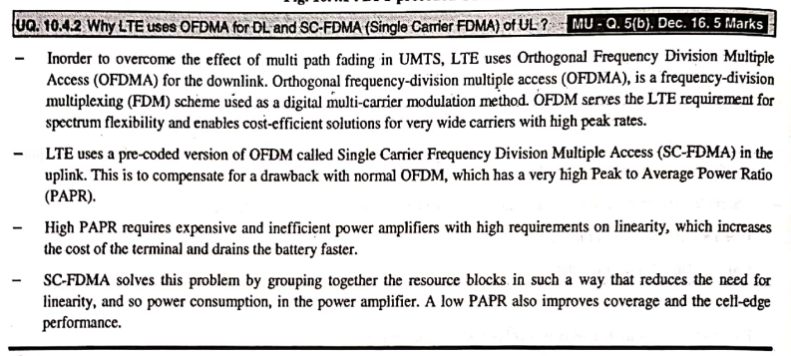

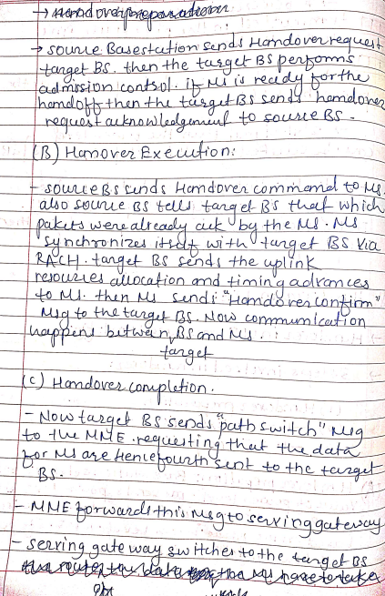

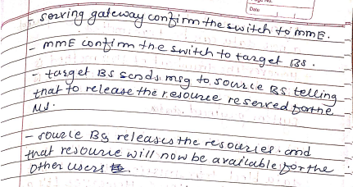

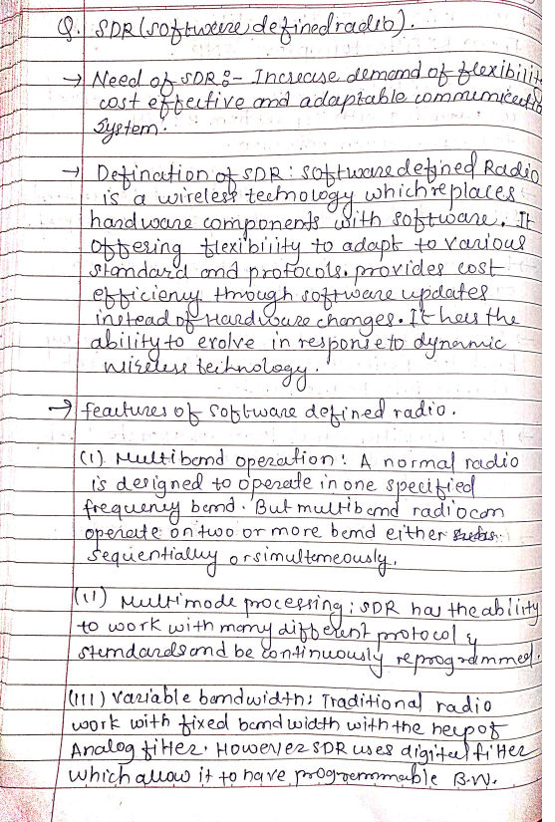

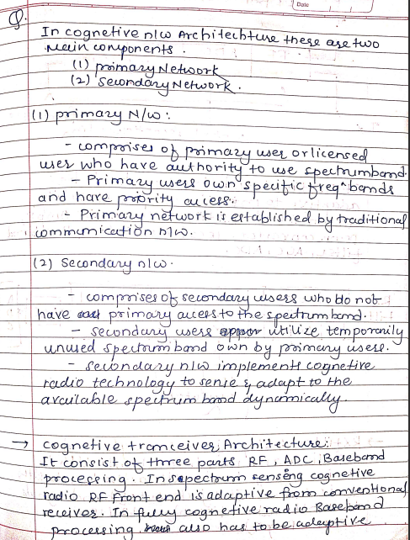

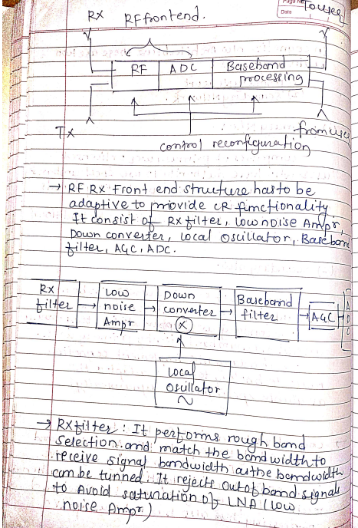

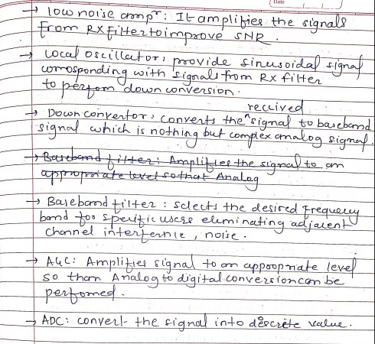

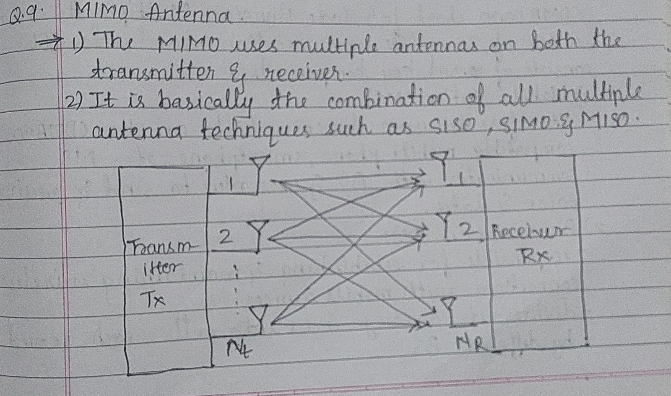

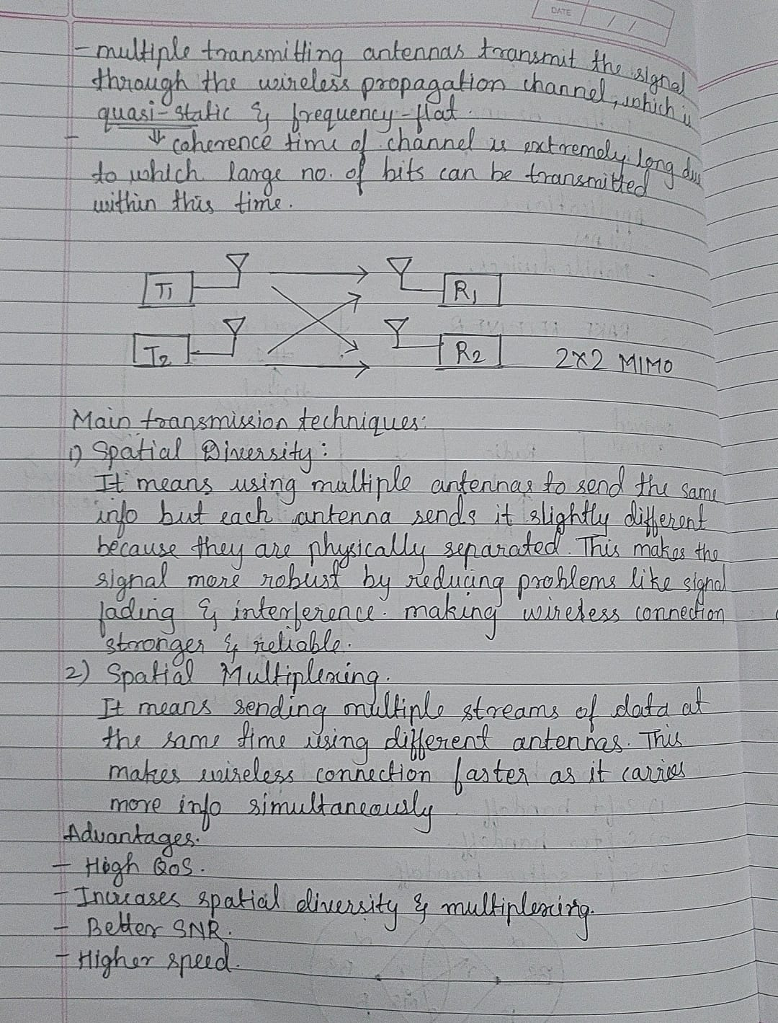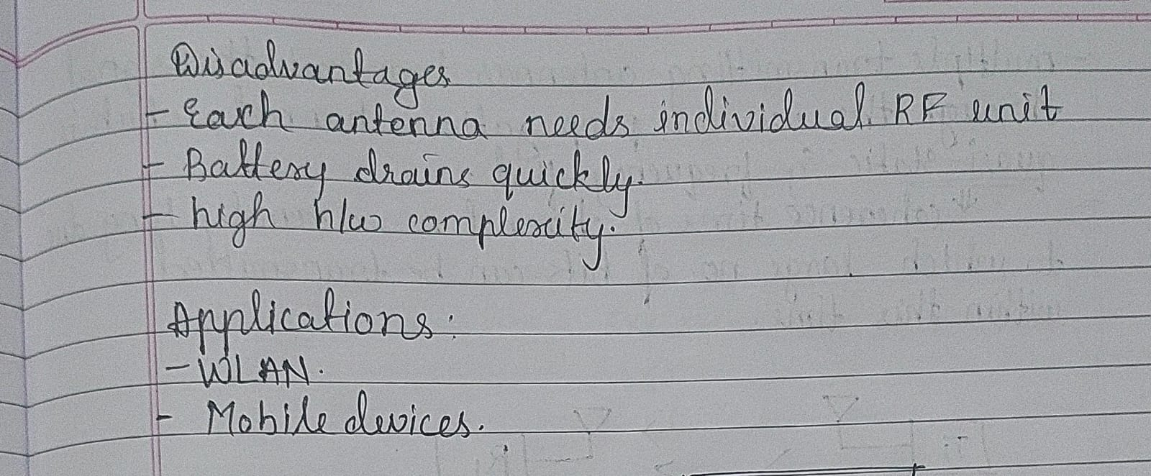

**What are the benefits of MIMO?**

* The multiple antennas can help in achieving the **higher data rate** through **spatial multiplexing** technique. It assists in getting the better uplink and downlink rate.
* The MIMO technology result in **reducing the Bit Error Rate** because of the advanced signal processing algorithm.
* The **fading effects minimized** by the MIMO based system because of the detailed signal travels to receiver’s end.
* The higher Quality of Service provided by the systems based on the MIMO offers an **increased level of spectral efficiency**.
* There is a **better coverage** supported by this technology that directly assists in supporting a **great number of subscribers in a cell.**
* The MIMO technology gets adopted in a great variety of wireless standards like **WLAN, LTE, WiMax, and LTE-Advanced**.

**What are drawbacks associated with the MIMO?**

* When compared with a single antenna based system, the MIMO **demand pretty much complex hardware**. There are individual RF units demanded by each antenna.
* **The power requirements increased** by the hardware resources in this technology. **It results in draining the battery at a faster rate** because of the increasing complexity and signal processing algorithms.
* The **cost of systems having MIMO is pretty higher** when compared to the individual antenna system.